On “the dangers of unchecked tradition”

All the data and associated references used in this letter can most easily be viewed at the following URL:
https://cheerful-wmcdannell.wordpress.com/2025/08/05/kings-of-judah-israel-timeline-biblical-data-only-wip

Premise:
Jerome, Flavius Josephus, the Seder Olam Rabbah (Talmud), the Targum of Jonathan, Louis Ginzberg, Adam Clarke, and Matthew Henry’s commentary all assert or give (only) the impression that the earthquake (Amos 1:1, 6:11, Zec 14:5) that occurred during the reign of Azariah/Uzziah/Ozias occurred at the same time as his transgression in the temple. It certainly sounds good and also creates a dramatic story. However, there’s a problem: that’s not the story that the Bible teaches us (1Thess 5:21).

Analysis:
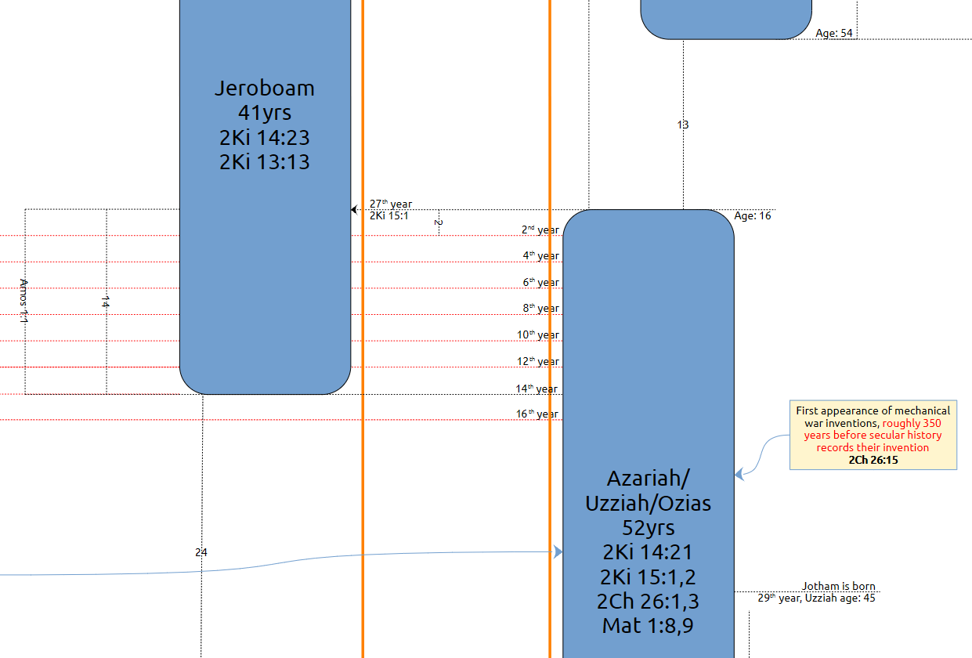

Uzziah’s reign began in the 27th year of Jeroboam (II) king of Israel (2Ki 15:1). That gives us two 14 year periods where both events of Amos 1:1 occurred, the latest date of which is the 16th year of Uzziah’s reign. Uzziah’s son Jotham, who was judge over the king’s house before his reign began (2Ki 15:5, 2Ch 26:21) wasn’t even born until the 29th year of Uzziah’s reign (see full chart for all references; Jotham/Joatham son of Uzziah began reigning at age 25 two years after the end of Uzziah’s 52 year reign).

Therefore, “the earthquake” הָרָעַשׁ (ha-ra‘ash) (Amos 1:1, Zech 14:5) occurred during the former half of Uzziah’s reign and his transgression in the temple occurred in the latter half of his reign. These facts sufficiently separate both events by enough time for us to know with certainty that they could not have occurred at the same time.

